**Lab 01 Task**



**Name Hammad Arshad**

**Roll no SU92-BSAIM-F23-030**

**Section BSAI-4A**

**Subject PAI (LAB)**

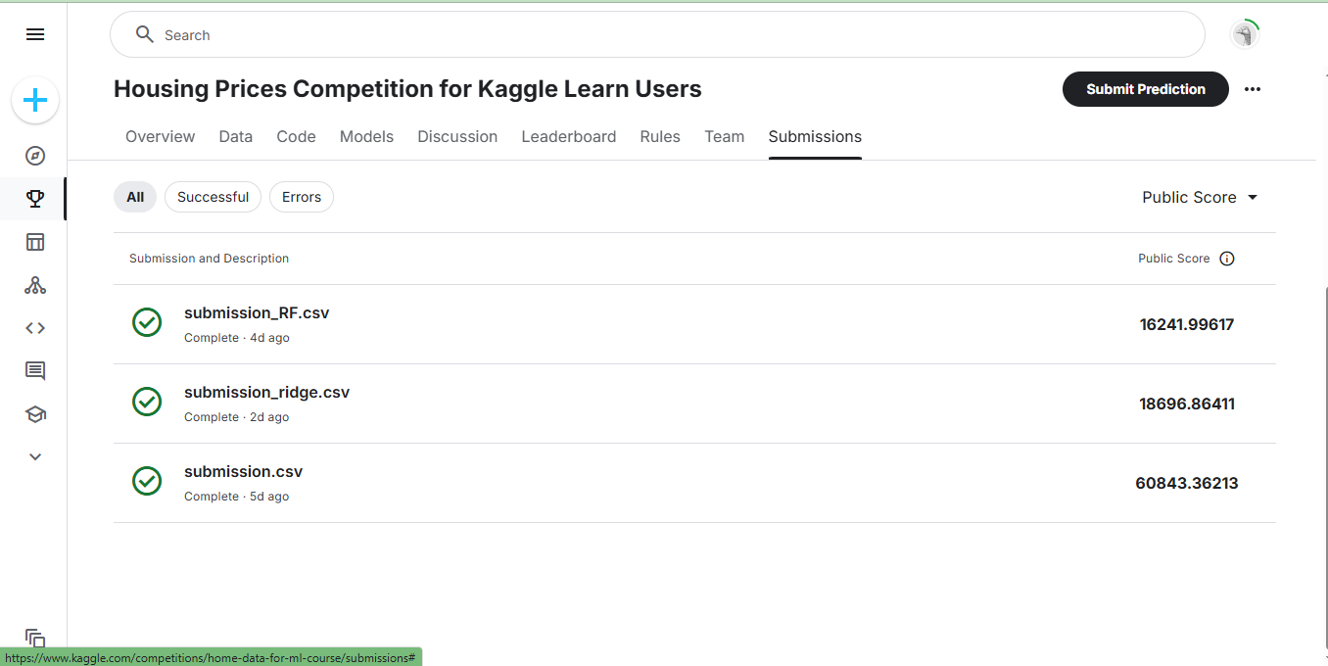

**House prediction System:**

I tested **three models** to predict house prices: **SVC, Ridge Regression, and Random Forest**. Each model gave different results, showing which one works best for this type of problem.

1. **SVC (Score: 60843.36)**  
   SVC is mainly used for classification, not for predicting numbers like house prices. Because of this, it performed very poorly and gave the highest error. It is not a good choice for this task.
2. **Ridge Regression (Score: 18696.8)**  
   Ridge Regression is good for numerical predictions and worked better than SVC. It tries to find a simple relationship between house prices and features. However, it still missed some complex patterns, which made it less accurate than Random Forest.
3. **Random Forest (Score: 16241.99)**  
   Random Forest gave the **best** results. It creates multiple decision trees and takes the best predictions. This helps it understand complex patterns in the data, making it the most accurate model among the three.

**Final Conclusion:**  
Among these models **Random Forest is the best** for predicting house prices. Ridge Regression is also decent but not as good. SVC is the worst choice because it is not made for this type of problem. So for this dataset **Random Forest is the most reliable option**.